Featured Apps

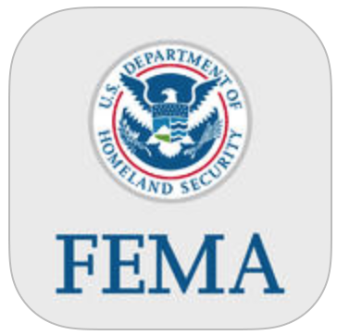
FEMA (USA)
iOS
https://itunes.apple.com/us/app/fema/id474807486?mt=8
Android
https://play.google.com/store/apps/details?id=gov.fema.mobile.android&hl=en
The FEMA App contains preparedness information for different types of disasters, an interactive checklist for emergency kits, a section to plan emergency meeting locations, information on how to stay safe and recover after a disaster, a map with FEMA Disaster Recovery Center locations (one-stop centers where disaster survivors can access key relief services) and Shelters, general ways the public can get involved before and after a disaster, and the FEMA blog.

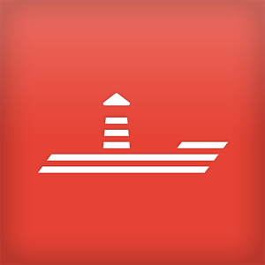
SIGNALERT
Android
https://play.google.com/store/apps/details?id=com.signalert
iOS
https://itunes.apple.com/us/app/signalert-app/id811283419?mt=8
SIGNALERT is the social network app for real-time alerting, witnessing, describing and sharing about natural and technological phenomenon, or accident that you may witness. Help to better understand the dangers and consequences in your neighbourhood, better react and improve emergency interventions. Floods, snowfalls, avalanches and soon many other phenomenon whether natural or from human origin, to be described with SIGNALERT.
With SIGNALERT, you can share information between close users in real time to get more details about dangerous events or that could become so on a site of your choice. You can learn about the effects caused by the observed phenomena, whether planned or not, and about the appropriate behaviours. Available in French and English

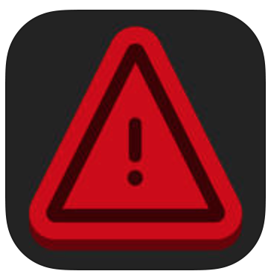
Emergency AUS (Australia)
iOS
https://itunes.apple.com/au/app/emergency-aus/id567636545?mt=8
Android
https://play.google.com/store/apps/details?id=com.gridstone.emergencyaus&hl=en
Emergency AUS delivers warning and incident information issued by official agencies across Australia. The ‘must have’ app for all Australians and visitors to help you get informed and stay up-to-date with emergencies that can impact you and your loved ones.

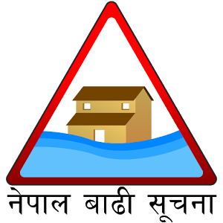
Nepal Flood Alert (Nepal)
Android
https://play.google.com/store/apps/details?id=np.com.rts.hydrology.ews&hl=en
A simple flood early warning system to save lives and property.
* Provides you an early warning notification/alarm on any flood possibility
* Enables you to constantly monitor the water level readings provided by multiple water stations established throughout the country
* Enables you to constantly monitor flow and trend of the rivers
* Personalize notifications according to your region or even current location (needs GPS)
* Has Nepali language support

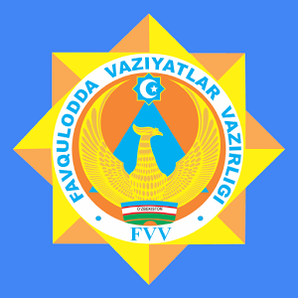
"SOS" МЧС Узбекистана (Uzbekistan)
Android
https://play.google.com/store/apps/details?id=uz.android.sos.mchs
- Call rescuers in emergency situations;
- Information on first aid;
- Information on how to act in one way or another critical situation;
- Information about the Ministry of Emergency Situations;
- News and ministry of the republic;
- Other useful information.
In order to use the mobile application you only need to download and register. Registration is required to emergency services were able to contact you by your service provider. No personal information other than your phone number is required.

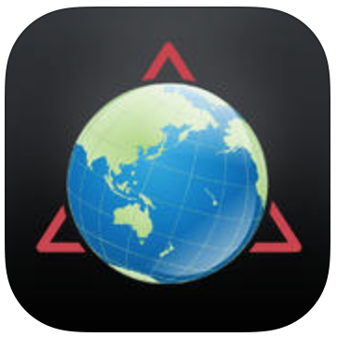
Disaster Alert
iOS
https://itunes.apple.com/app/disaster-alert-pacific-disaster/id381289235?mt=8
Android
https://play.google.com/store/apps/details?id=disasterAlert.PDC&hl=en
Disaster Alert (by Pacific Disaster Center) is a free download providing mobile access to multi-hazard monitoring of and early warning for “Active Hazards” around the globe. Additional information and reports about hazards can be viewed and shared.

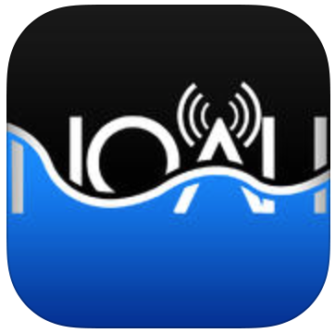
DOST Project NOAH (Philippines)
Android
https://play.google.com/store/apps/details?id=ph.gov.dost.noah.android&hl=en
iOS
https://itunes.apple.com/ph/app/dost-project-noah/id586126663?mt=8
It aims to give mobile device users information such as probability of rain, typhoon forecast, images from multifunctional transport satellites, rainfall amount, temperature, images from Doppler stations and recordings from weather stations, stream gauges and rain gauges -- essentially giving users access to crucial hazards information right at their fingertips.

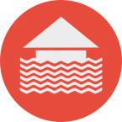
Jakarta Flood Alert (Indonesia)
Android
https://play.google.com/store/apps/details?id=com.siagabanjir
Flood Alert is an application to monitor the height of the water above the door of the city. When the rainy season arrives, the height of each sluice will experience erratic changes and can be a danger as the weather gets worse.

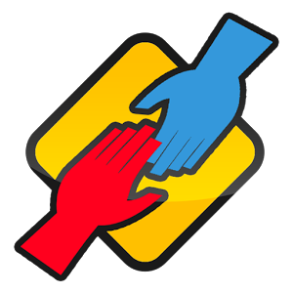
iLigtas (Philippines)
Android
https://play.google.com/store/apps/details?id=com.gcccs.org.iligtas
iOS
https://itunes.apple.com/us/app/iligtas/id882846085?mt=8
Prepares you for disaster, helps during disaster, and provides means for recovery after a disaster. It collects data through crowdsourcing via SMS, geotagging, and social media feeds, and then creates infographics and provides relevant data to LGU's and NGO's for a more disaster resilient Philippines

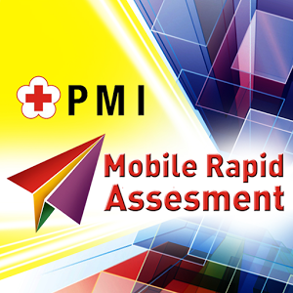
PMI Mobile Rapid Assessment (Indonesia)
Android
https://play.google.com/store/apps/details?id=com.ecc.dma&hl=en
MRA application is used to report the disaster, the impact, the victim,
and needs, which can be done either by the Red Cross volunteers and the general public direct from the scene in the entire territory of the Republic of Indonesia,
These applications can use the GPS or without GPS facility and an internet connection from your device. This application is used only to report emergencies directly from the site. PMI is not obligated to respond or provide assistance to each report

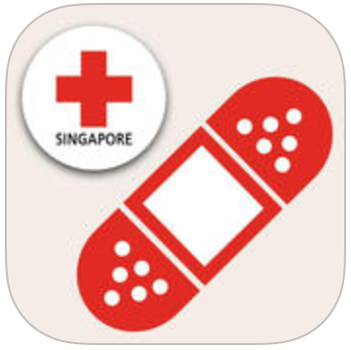
First Aid by Singapore Red Cross (Singapore)
iOS
https://itunes.apple.com/sg/app/first-aid-by-singapore-red/id911802632?mt=8
Android
https://play.google.com/store/apps/details?id=com.cube.gdpc.sgp
Simple. Free. It can save a life. The official Singapore Red Cross First Aid app gives you instant access to the information you need to know to handle the most common first aid emergencies. With videos, interactive quizzes and simple step-by-step advice it's never been easier to know first aid.

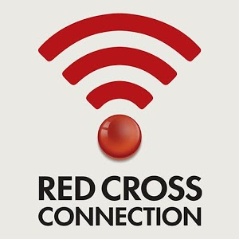
Red Cross Connection (Singapore)
Android
https://play.google.com/store/apps/details?id=com.redcross.redcross&hl=en
iOS
https://itunes.apple.com/us/app/red-cross-connection/id725437598?mt=8
Red Cross Connection lets you:
• Receive and share alerts for needed blood types and the amount needed
• Track your contributions, lives saved, shares and when you can donate next
• View your friends on the network and invite others to join
• Locate the nearest donation centre
• Check-in at the centre to inspire your friends to answer the alert
• Receive invitations to Red Cross donation drives and events

